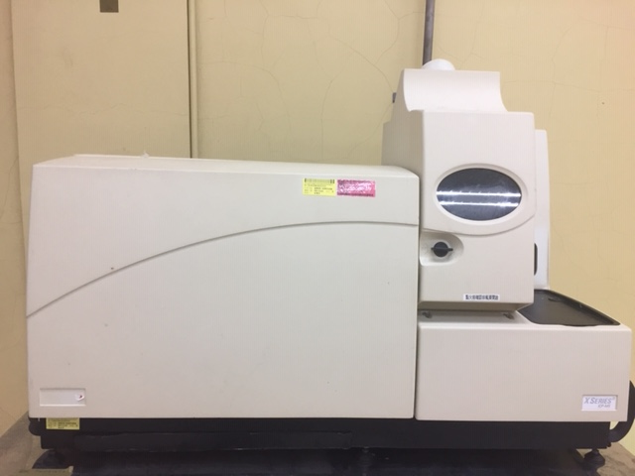
採購日期: 095/12/20
廠牌: Thermo XSeries ^{II}

